Internet Acceptable Use Policy

Ballinacarriga National School

SCOIL BÉAL NA CARRAIGE

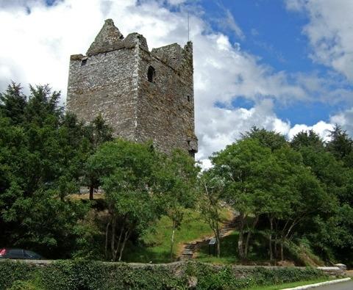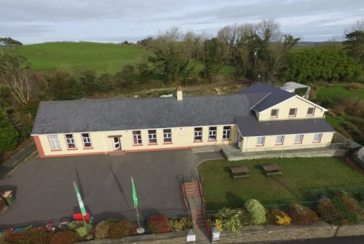

General Approach

The aim of this Internet Acceptable Use Policy (AUP) is to ensure that pupils will benefit from the learning opportunities offered by the school’s internet resources in a safe and effective manner.
Internet use and access is considered a school resource and privilege. If the school AUP is not adhered to this privilege may be withdrawn and appropriate sanctions will be imposed.

When using the internet pupils, parents and staff are expected:

- To treat others with respect at all times.
- Not undertake any actions that may bring the school into disrepute.
- Respect the right to privacy of all other members of the school community.

This Acceptable Use Policy applies to pupils who have access to and are users of the internet in Ballinacarriga NS .

Misuse of the internet may result in disciplinary action, including written warnings, withdrawal of access privileges, detention and, in extreme cases, suspension or expulsion. The school also reserves the right to report any illegal activities to the appropriate authorities.

If a staff member is made aware of incidents of inappropriate online behaviour that take place out of school Ballinacarriga NS will inform parents/carers.

Ballinacarriga NS implements the following strategies on promoting safer use of the internet :

- Pupils will be provided with education in the area of internet safety as part of our implementation of the SPHE curriculum.

This policy and its implementation will be reviewed when necessary by the following stakeholders:

- Board of Management, teaching staff, and support staff.

This policy has been developed by a working group including: Principal, Deputy Principal and teachers

Should serious online safety incidents take place, The Principal/Deputy Principal should be informed.

Content Filtering

Ballinacarriga NS has chosen to implement the following level on content filtering on the Schools Broadband Network:

- Level 4 This level allows access to millions of websites including games and YouTube but blocks access to websites belonging to the personal websites category and websites such as Facebook belonging to the Social Networking category.

Pupils taking steps to by-pass the content filter by using proxy sites or other means may be subject to disciplinary action, including written warnings, withdrawal of access privileges, detention and, in extreme cases, suspension or expulsion.

Web Browsing and Downloading

Pupils will not intentionally visit internet sites that contain obscene, illegal, hateful or otherwise objectionable materials.

Pupils will report accidental accessing of inappropriate materials in the classroom to their teacher.

Pupils and staff will be aware that any usage, including distributing or receiving information, school-related or personal, may be monitored for unusual activity, security and/or network management reasons.

Pupils will use the school’s internet connection only for educational activities.

Pupils will not engage in online activities such as uploading or downloading large files that result in heavy network traffic which impairs the service for other internet users.

Pupils will not download or view any material that is illegal, obscene, and defamatory or that is intended to annoy or intimidate another person.

Downloading by pupils of materials or images not relevant to their studies is not allowed.

Email and Messaging

The use of personal email accounts is only allowed at Ballinacarriga NS with expressed permission from members of the teaching staff.

Pupils should not use school email accounts to register for online services such as social networking services, apps, and games.

Pupils will use approved class email accounts only under supervision by or permission from a teacher.

Pupils will not send any material that is illegal, obscene, and defamatory or that is intended to annoy or intimidate another person.

Pupils should immediately report the receipt of any communication that makes them feel uncomfortable, is offensive, discriminatory, threatening or bullying in nature and must not respond to any such communication.

Pupils should ask their teacher before opening emails from unknown senders.

Social Media

The following statements apply to the use of messaging, blogging and video streaming services in Ballinacarriga NS :

Use of instant messaging services and apps including Snapchat, WhatsApp, G Chat, TikTok, etc. is not allowed in Ballinacarriga NS.

Use of blogs such as Word Press, Tumblr etc. is allowed in Ballinacarriga NS with express permission from teaching staff.

Use of video streaming sites such as YouTube and Vimeo etc. is with express permission from teaching staff.

Staff and pupils must not use social media and the internet in any way to harass, insult, abuse or defame pupils, their family members, staff, other members of the Ballinacarriga NS community

Staff and pupils must not discuss personal information about pupils, staff and other members of the Ballinacarriga NS community on social media.

Staff and pupils must not use school email addresses for setting up personal social media accounts or to communicate through such media.

Staff and pupils must not engage in activities involving social media which might bring Ballinacarriga NS into disrepute.

Staff and pupils must not represent their personal views as those of being Ballinacarriga NS on any social medium.

Personal Devices

In the normal day to day running of Ballinacarriga NS, the use of personal internet-enabled devices is forbidden. This includes attending matches, school tours or other school based activities. However occasionally if pupils are permitted to bring in their own devices the following rules apply:
Pupils using their own technology in school should follow the rules set out in this agreement, in the same way as if they were using school equipment.

Pupils are only allowed to bring personal internet-enabled devices into Ballinacarriga NS with expressed permission from staff.

Images & Video
Care should be taken when taking photographic or video images that pupils are appropriately dressed and are not participating in activities that might bring the individuals or the school into disrepute.

At Ballinacarriga NS pupils must not take, use, share, publish or distribute images of others without their permission.

Taking photos or videos on school grounds or when participating in school activities is only allowed with expressed permission from staff.

Pupils must not share images, videos or other content online with the intention to harm another member of the school community regardless of whether this happens in school or outside.

Sharing explicit images and in particular explicit images of pupils and/or minors is an unacceptable and absolutely prohibited behaviour, with serious consequences and sanctions for those involved. Sharing explicit images of other pupils automatically incurs suspension as a sanction.

We advise parents that if they take photographs of children at school events that they seek permission from parents/guardians of all children in the photographs/videos before sharing them online.

Cyberbullying

When using the internet pupils, parents and staff are expected to treat others with respect at all times.

Engaging in online activities with the intention to harm, harass, or embarrass another pupil or member of staff is an unacceptable and absolutely prohibited behaviour, with serious consequences and sanctions for those involved.

Measures are taken to ensure that staff and pupils are aware that bullying is defined as unwanted negative behaviour, verbal, psychological or physical, conducted by an individual or group against another person (or persons) and which is repeated over time. This definition includes cyber-bullying even when it happens outside the school or at night.

Isolated or once-off incidents of intentional negative behaviour, including a once-off offensive or hurtful text message or other private messaging, do not fall within the definition of bullying and will be dealt with, as appropriate, in accordance with the school’s code of behaviour.

School Websites
The website will be regularly checked to ensure that there is no content that compromises the safety, privacy, or reputation of students or staff.

The publication of student work will be coordinated by a teacher.

Personal student information including home address and contact details will not be published on Ballinacarriga NS web pages.

The Ballinacarriga NS website will avoid publishing the first name and last name of pupils in video or photograph captions published online.

Distance Learning
● In circumstances where teaching cannot be conducted on the school premises, teachers will email parents and may use Seesaw and Zoom to assist with remote teaching where necessary.
(Other platforms may be introduced in the future)
● The school has signed up to the terms of service of the Online Platforms in use by the school.
● The School has enabled the most up to date security and privacy features which these Online Platforms provide.
● Parents/guardians will be provided with the password and will be expected to monitor their child’s use of the online platforms.
● If teachers are using Zoom, parents/guardians can consent by submitting their own email address for their child to access lessons on Zoom.
● Parents/guardians must also agree to monitor their child’s participation in any such lessons conducted on the Online Platforms.
Guidelines for Respectful Online Communication
- Under no circumstances can pictures or recordings be taken of video calls.
- Staff, families and students are expected to behave in an appropriate, safe, respectful and kind manner online.
- It is the duty of parents/guardians to supervise children while they are working online and to ensure any content which they are submitting to their teacher is appropriate.
Guidelines for staff members using online communication methods:
- Under no circumstances can pictures or recordings be taken of video calls.
- Staff members will communicate with pupils and families during the hours of 8.30am - 3pm, where possible.
- Staff members will have high expectations regarding pupil behaviour, with any communication which takes place online.
- Staff members will notify parents/guardians of the date, time and password for a video call via email.
- Staff members will only admit participants to video conferences, if they recognise the email address/username as being connected to a pupil.
Rules for pupils using online communication methods:
For submitting learning:
- Submit work and pictures that are appropriate - have an adult take a look at your work before you send it.
- Use kind and friendly words.
For video calls/Zoom:
- Pictures or recordings of the video call are not allowed.
- Remember to ensure you join each Zoom meeting using your family name.
- Remember our school rules - they are still in place, even online.
- Set up your device in a quiet space, with no distractions in the background.
- Join the video with your microphone muted.
- Raise your hand before speaking, just like you would do in class.
- If you have the chance to talk, speak in your normal voice, using kind and friendly words.
- Show respect by listening to others while they are speaking.
- Ensure that you are dressed appropriately for the video call.
- Be on time - set a reminder if it helps.

Guidelines for parents and guardians:
For learning
- It is the responsibility of parents and guardians to ensure that pupils are supervised while they work online.
- Check over the work which pupils send to their teacher, ensuring it is appropriate.
- Continue to revise online safety measures with pupils.
For more information on Seesaw’s privacy and GDPR policies please go to https://web.seesaw.me/privacy-policy
For video calls/Zoom
- Under no circumstances can pictures or recordings be taken of video calls.
- Ensure that the school has the correct email address for inviting you to join apps and meetings.
- The main purpose of a video call is to maintain a social connection between the school staff and pupils at this difficult time. Encourage pupils to listen and enjoy the experience.
- Please note that school staff will only accept users into video call if you can be identified by the display name on your zoom account.

For detailed information on GDPR and Zoom, please visit https://zoom.us/privacy

This policy was ratified by the Board of Management on _____________
Signed by ____________________ Donal O Brien, Chairpers
Permission Form

As the parent or legal guardian of the student named below, I have read the Acceptable Use Policy (available on the school website) and grant permission for my son or daughter or the child in my care to access the Internet. I understand that Internet access is intended for educational purposes. I also understand that every reasonable precaution has been taken by the school to provide for online safety but the school cannot be held responsible if students access unsuitable websites.
In relation to the school website, I accept that, if the school considers it appropriate, my child’s schoolwork may be chosen for inclusion on the website. I understand and accept the terms of the Acceptable Use Policy relating to publishing students’ work on the school website.

Parent’s Signature: _____________________________

Name of Student:______________________

Date: ___________________

