Safeguarding Statement for
Ballinacarriga National School
SCOIL BÉAL NA CARRAIGE
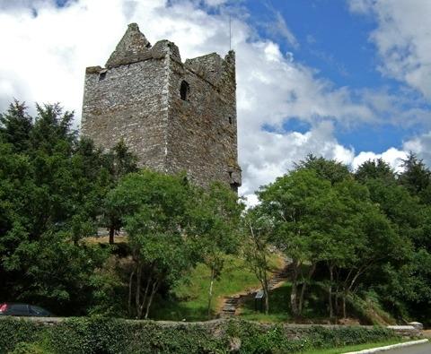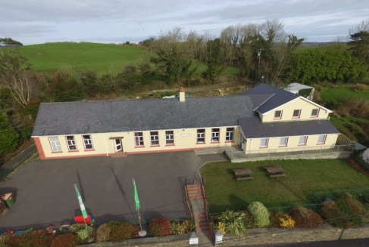

About our organisation:
➪ Name: Ballinacarriga Mixed National School
➪Location: Ballinacarriga, Dunmanway, Co. Cork.
➪Number of staff: 5 teachers, 1 visiting teacher, 1 SNAs and a secretary.
About the services provided:
We are a mixed Catholic primary school. Our school is broken into 4 classrooms and also has 2 support teaching rooms. We are open each school day from 9.10am – 1.50pm for infants and 9.10am – 2.50pm for 1st – 6th class.
About your service users:
- We cater for children aged between 4-13 years.
- The children in our school have a wide range of ability. Some of the children in our care have specific care needs which are referred to in our SEN policy and catered for by teaching staff and Special Needs Assistants.
- The 4 classrooms are broken up as follows:
  - Junior and Senior infants
  - 1st & 2nd class
  - 3rd & 4th class
  - 5th & 6th class
Designated Liaison Person (DLP): Róisín Hurley (Principal)
The Deputy Designated Liaison Person (Deputy DLP): Ailish Kelly (Deputy Principal)
In accordance with the requirements of the Children First Act 2015, Children First: National Guidance for the Protection and Welfare of Children 2017, the Child Protection Procedures for Primary and Post Primary Schools 2017 and Tusla Guidance on the preparation of Child Safeguarding Statements, the Board of Management of Ballinacarriga NS has agreed the Child Safeguarding Statement set out in this document.
The Board of Management has adopted and will implement fully and without modification the Department’s Child Protection Procedures for primary and post-primary Schools 2017 as part of this overall Child Safeguarding Statement.
The Board of Management recognises that child protection and welfare considerations permeate all aspects of school life and must be reflected in all of the school’s policies, procedures, practices and activities. The school will adhere to the following principles of best practice in child protection and welfare. The school will:

  - recognise that the protection and welfare of children is of paramount importance, regardless of all other considerations
  - fully comply with its statutory obligations under the Children First Act 2015 and other relevant legislation relating to the protection and welfare of children
  - fully co-operate with the relevant statutory authorities in relation to child protection and welfare matters
  - adopt safe practices to minimise the possibility of harm or accidents happening to children and protect workers from the necessity to take unnecessary risks that may leave themselves open to accusations of abuse or neglect
  - develop a practice of openness with parents and encourage parental involvement in the education of their children; and
  - fully respect confidentiality requirements in dealing with child protection matters

The following procedures/measures are in place:

- In relation to any member of staff who is the subject of any investigation (howsoever described) in respect of any act, omission or circumstance in respect of a child attending the school, the school adheres to the relevant procedures set out in Chapter 7 of the Child Protection Procedures for Primary and Post-Primary Schools 2017 and to the relevant agreed disciplinary procedures for school staff which are published on the DES website
- In relation to the selection or recruitment of staff and their suitability to work with children, the school adheres to the statutory vetting requirements of the National Vetting Bureau (Children and Vulnerable Persons) Acts 2012 to 2016 and to the wider duty of care guidance set out in relevant Garda vetting and recruitment circulars published by the DES and available on the DES website
- In relation to the provision of information and, where necessary instruction and training to staff in respect of the identification of the occurrence of harm (as defined in the 2015 Act) the school:
    - Has provided each member of staff with a copy of the school’s Child Safeguarding Statement
    - Ensures all new staff are provided with a copy of the school’s Child Safeguarding Statement
    - Encourages staff to avail of relevant training
    - Encourages Board of Management members to avail of relevant training
    - The Board of Management maintains records of all staff and Board member training.

- In relation to reporting of child protection concerns to Tusla, all school personnel are required to adhere to the procedures set out in the Child Protection Procedures for Primary and Post-Primary Schools 2017, including in the case of registered teachers, those in relation to mandated reporting under the Children First Act 2015
- In this school, the Board has appointed the above named DLP as the ‘relevant person’ (as defined in the Children First Act 2015) to be the first point of contact in respect of the school’s child safeguarding statement.

All registered teachers employed by the school are mandated persons under the Children First Act 2015.
In accordance with the Children First Act 2015, the Board has carried out an assessment of any potential for harm to a child while attending the school or participating in school activities. A written assessment setting out the areas of risk identified and the school’s procedures for managing those risks is attached as an appendix to these procedures.

This statement has been published on the school’s website and has been provided to all members of school personnel, the Parents’ Association and the patron. It is readily accessible to parents and guardians on request. A copy of this Statement will be made available to Tusla and the Department if requested.

This Child Safeguarding Statement will be reviewed annually or as soon as practicable after there has been a material change in any matter to which this statement refers.

Checklist: Child Protection Risks
 |  | Risk |  | Risk of Harm | Managing the Risk | Ranking the Risk
1. |  | Potential for abuse by employee/volunteer/parents |  | - Harm to pupils | - Vetting Procedures  - Child Protection Procedures | High
2. |  | Working alone with children/one to one teaching |  | - Harm by school personnel | - Glass Panels in doors  - SEN Policy | High
3. |  | Care of Pupils with SEN including intimate care |  | - Inappropriate behaviour  - Harm to pupil | - SEN Policy  - Intimate care policy  - Agreed procedures between parent and staff signed | High
4. |  | Sports Coaches |  | - Harm to pupil | - Vetting  - Supervision by staff member at all times | High
5. |  | Use of IT and Communication technology by pupils |  | - Bullying  - Exposure to inappropriate material | - Anti bullying  - Code of behaviour  - Acceptable Usage Policy  - Safety Settings | Medium
6. |  | Training of school staff in Child Protection procedures |  | - Abuse not detected or properly reported | - Ensure training in “Children First” is arranged for all school staff | Medium
 |  | Risk |  | Risk of Harm | Managing the Risk | Ranking the Risk
7. |  | Substitute teacher or SNA’s |  | - Abuse not detected or properly reported | - DLP & DDLP names clearly visible at school entrance  - Child Safeguarding Statement visible at school entrance | Medium
8. |  | Toilet Areas |  | - Inappropriate behaviour  - Bullying | - One at a time rule.  - Intimate care policy | High
9. |  | Curricular Provision in respect of SPHE, RSE & Stay Safe |  | - Non-teaching of same | - School fully implements Walk Tall, RSE & Stay Safe | Low
10 |  | Daily arrival & dismissal of pupils |  | - Harm from other children or unknown adults | - Supervision Policy  - Students not to arrive before 8.50am | Medium
11. |  | Students participating in work experience in our school |  | - Harm to pupils  - Abuse not detected or properly reported | - Garda clearance when over 16  - Supervision Policy  - Child Safeguarding Statement | Medium
12. |  | Sporting activities/outings |  | - Harm to pupils  - Bullying | - Supervision Policy  - Anti-bullying policy.  - Code of behaviour | Medium
13. |  | School tours/outings including trips to hall, pitch, church, other schools, etc. |  | - Harm to pupils  - Bullying | - Code of behaviour  - Anti-bullying Policy  - Supervision Policy | Medium
 |  | Risk |  | Risk of Harm | Managing the Risk | Ranking the Risk
14. |  | Fundraising events |  | - Harm to pupils  - Bullying | - Supervision Policy  - Responsibility lies with parents  - Code of behaviour  - Anti-bullying Policy | High
15. |  | School transport arranged (bus hire or parents lifts) |  | - Harm to pupils | - Supervision Policy  - Vetting Procedures | High
16. | Administration of First Aid |  | - Harm to pupil  - Inappropriate behaviour |  | Supervision Policy  Injuries & Accidents Policy (not in place yet) |  | Medium
17 | Use of external personnel to supplement curriculum |  | - Harm to pupil  - Abuse not detected or properly reported |  | Supervision Policy |  | Medium
18. | Recruitment of new school personnel |  | - Harm to pupils  - Abuse not detected or reported properly |  | - Vetting Procedures  - Child Safeguarding statement, DES procedures made available to all staff  - Reference from past employer |  | Medium
19. | Student teachers undertaking placement |  | - Harm to pupils  - Abuse not detected or reported properly |  | - Vetting Procedures  - Supervision Policy |  | Medium
20. | Swimming |  | - Harm to pupil  - Inappropriate behaviour |  | - Supervision policy  - Vetting procedures |  | High
21. | Christmas concert (dress rehearsal) |  | - Harm to pupil  - Inappropriate behaviour  - Bullying |  | - Supervision policy  - 2 adults with a group of children |  | Medium

This Child Safeguarding Statement was adopted by the Board of Management on 19th Sept 2019.
It will be reviewed in September 2020
Signed: _____________________ Signed: ______________________________
Chairperson of BoM Principal/Secretary to the BoM
Date: 19th Sept 2019 Date: 19th Sept 2019

List of Mandated persons under the Act:
Registered teachers:
Róisín Hurley
Ailish Kelly
Claire Nagle
Eleanor McSweeney
Barry O Driscoll
Liz Twomey (visiting teacher)
Margaret Burke (visiting teacher)

